IGB100 Playtesting Report

Carnival of Carnage

Jacob Stevenson

N10799575

Group 28

# Playtesting Plan

|  |  |  |  |  |  |  |  |
| --- | --- | --- | --- | --- | --- | --- | --- |
| **Date** | **Participants** | | **Overall approach, including resources required** | **Session Goal** | **Method** | | **How to Analyse** |
| **Number** | **Who (characteristics of your play-testers)** | **What to measure** | **How to test** |
| 29/04/2023 | 1 | Naïve playtester | Will sit player in and allow them to test mechanics, encourage them to verbalize thoughts. | Discover how mechanics feel and if tweaks need to be made | Player satisfaction | Let player experiment with mechanics | Acquire feedback as to satisfaction levels |

# Summary of Results

|  |  |  |  |
| --- | --- | --- | --- |
| **Issue Description** | **Severity** | **Strategy to Address Issue** | **Other Notes** |
| Enemy needs to be faster | Moderate | Will tweak enemy speed to be more threatening | … |
| Door doesn’t say you don’t have enough items | Low | Will add more code to fix | … |
| Needs something to tell you the objective | Low | Will add UI element to explain | … |
| Enemy just chases, doesn’t patrol | High | Will add more complex AI during development |  |
| Death/Game Over screen | Moderate | Will add death and game over screen during development |  |
| Could use a timer to encourage replayability | Low | Potential addition to gameplay. Will add if enough time |  |

# Discussion of Feedback

*Overall feedback was mostly aimed at minor tweaks and additions to make gameplay feel better. The enemy wasn’t fast enough so it felt like there was little threat, slight confusion over not being informed why you need to collect items and the door not saying you don’t have enough items to unlock it.*

*These are overall simple fixes/additions, some will be addressed before final development, some will require more time. The death/game over screen will also include a level reset so the player can restart and continue.*

*The biggest concern is the enemy simply chasing as opposed to patrolling. This will be addressed during final development as it’s a rather complicated script and I’m not confident enough to finalize it before submission of the prototype.*

*A final note was a timer to keep track of how long it’s taking you to complete the game as a way to encourage replayability.*

# Supplementary Materials

No supplementary materials used.

# Game Screenshots

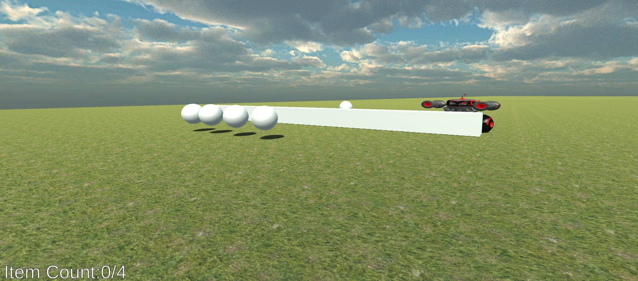

Game at the start

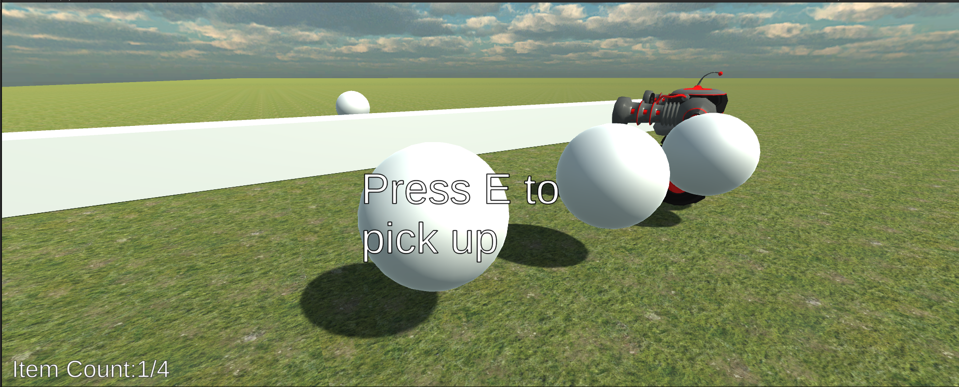

Game with one item picked up, aswell as showcasing the text display on items

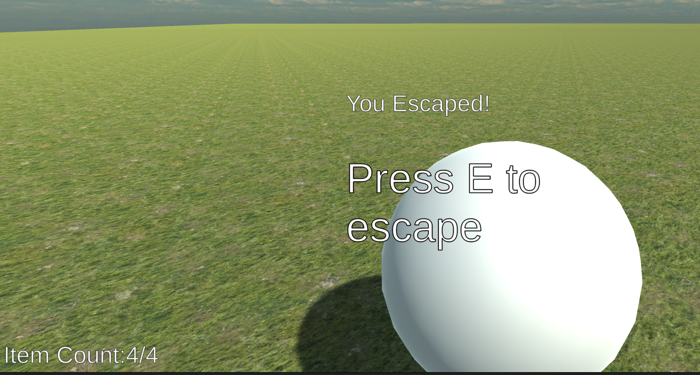

Game at the end, player having escaped